CS300 Proj2

Diyang Yu

April 1, 2017

# Get the pixels values. Now you will have 50 x 50 pixels.  
  
library(jpeg)  
jpg1 <- readJPEG("face1.jpg")  
jpg2 <- readJPEG("face2.jpg")  
jpg3 <- readJPEG("face3.jpg")  
jpg4 <- readJPEG("face4.jpg")  
jpg5 <- readJPEG("face5.jpg")  
jpg6 <- readJPEG("face6.jpg")  
jpg7 <- readJPEG("face7.jpg")  
jpg8 <- readJPEG("face8.jpg")  
jpg9 <- readJPEG("face9.jpg")  
jpg10 <- readJPEG("face10.jpg")

# Orginal pictures

grays = rgb(red = 0:255/255, blue = 0:255/255, green = 0:255/255)  
heatmap(jpg1,Rowv=NA,Colv=NA,col=grays, scale = "none")

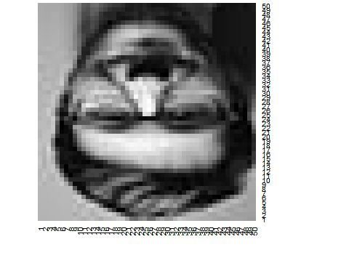

heatmap(jpg2,Rowv=NA,Colv=NA,col=grays, scale = "none")

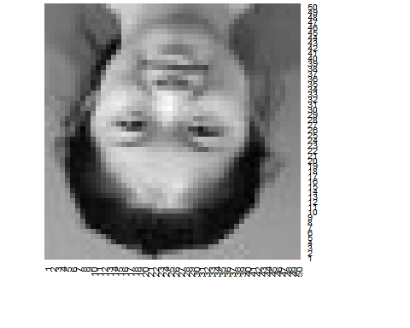

heatmap(jpg3,Rowv=NA,Colv=NA,col=grays, scale = "none")

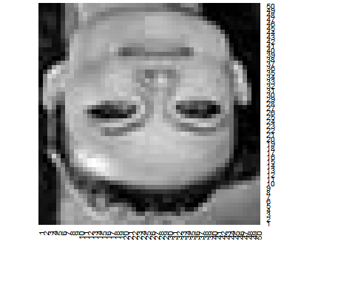

heatmap(jpg4,Rowv=NA,Colv=NA,col=grays, scale = "none")

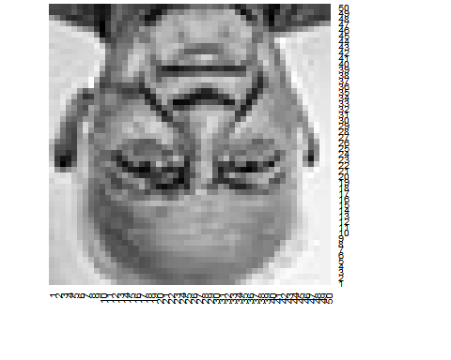

heatmap(jpg5,Rowv=NA,Colv=NA,col=grays, scale = "none")

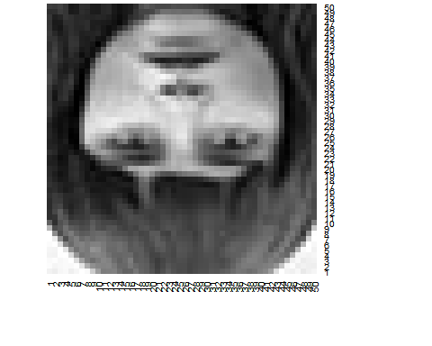

heatmap(jpg6,Rowv=NA,Colv=NA,col=grays, scale = "none")

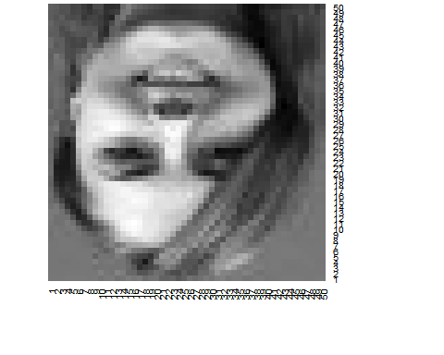

heatmap(jpg7,Rowv=NA,Colv=NA,col=grays, scale = "none")

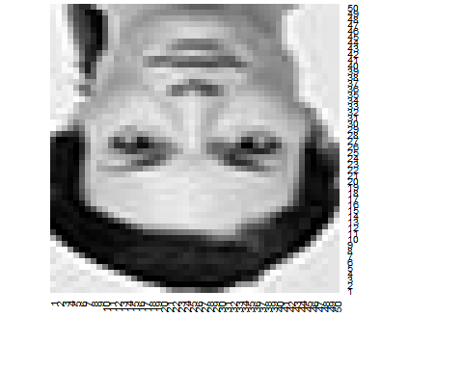

heatmap(jpg8,Rowv=NA,Colv=NA,col=grays, scale = "none")

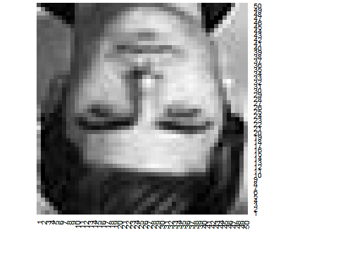

heatmap(jpg9,Rowv=NA,Colv=NA,col=grays, scale = "none")

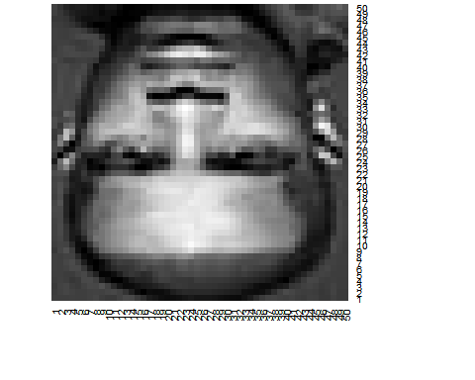

heatmap(jpg10,Rowv=NA,Colv=NA,col=grays, scale = "none")

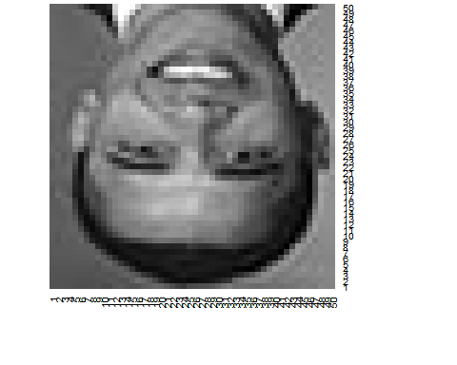

# Represent every image I as a vector T. Now for each image you will have n^2x1 vector.  
  
vec1 <- as.vector(jpg1)  
vec2 <- as.vector(jpg2)  
vec3 <- as.vector(jpg3)  
vec4 <- as.vector(jpg4)  
vec5 <- as.vector(jpg5)  
vec6 <- as.vector(jpg6)  
vec7 <- as.vector(jpg7)  
vec8 <- as.vector(jpg8)  
vec9 <- as.vector(jpg9)  
vec10 <- as.vector(jpg10)  
  
#Compute the average face vector and subtract the mean face.  
  
bigvec <- cbind(vec1,vec2,vec3,vec4,vec5,vec6,vec7,vec8,vec9,vec10)  
mean <- rowMeans(bigvec)  
  
newvec1 <- vec1 - mean  
newvec2 <- vec2 - mean  
newvec3 <- vec3 - mean  
newvec4 <- vec4 - mean  
newvec5 <- vec5 - mean  
newvec6 <- vec6 - mean  
newvec7 <- vec7 - mean  
newvec8 <- vec8 - mean  
newvec9 <- vec9 - mean  
newvec10 <- vec10 - mean

# Display the pictures.

dim(newvec1) <- c(50,50)  
dim(newvec2) <- c(50,50)  
dim(newvec3) <- c(50,50)  
dim(newvec4) <- c(50,50)  
dim(newvec5) <- c(50,50)  
dim(newvec6) <- c(50,50)  
dim(newvec7) <- c(50,50)  
dim(newvec8) <- c(50,50)  
dim(newvec9) <- c(50,50)  
dim(newvec10) <- c(50,50)  
dim(mean) <- c(50,50)  
  
heatmap(newvec1,Rowv=NA,Colv=NA,col=grays, scale = "none")

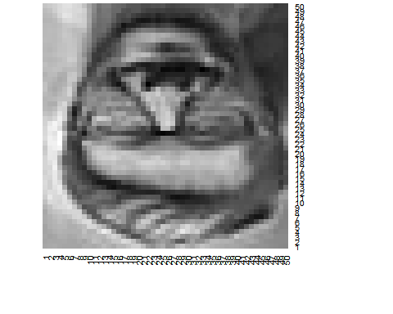

heatmap(newvec2,Rowv=NA,Colv=NA,col=grays, scale = "none")

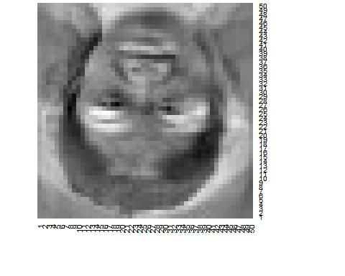

heatmap(newvec3,Rowv=NA,Colv=NA,col=grays, scale = "none")

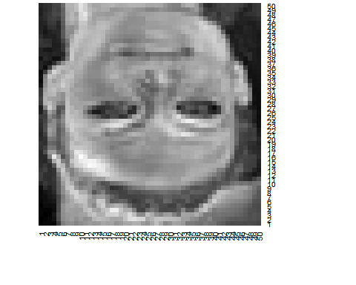

heatmap(newvec4,Rowv=NA,Colv=NA,col=grays, scale = "none")

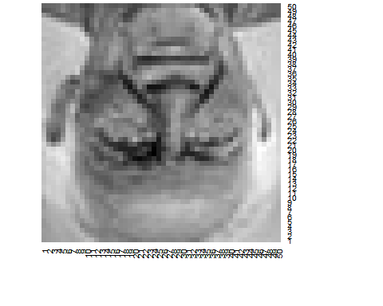

heatmap(newvec5,Rowv=NA,Colv=NA,col=grays, scale = "none")

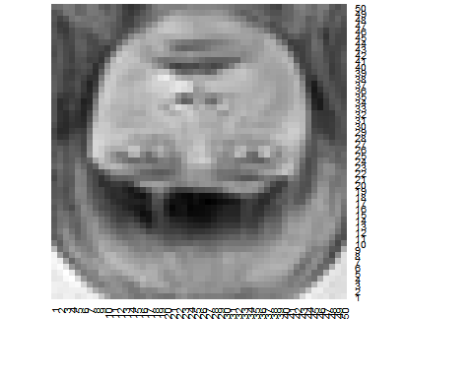

heatmap(newvec6,Rowv=NA,Colv=NA,col=grays, scale = "none")

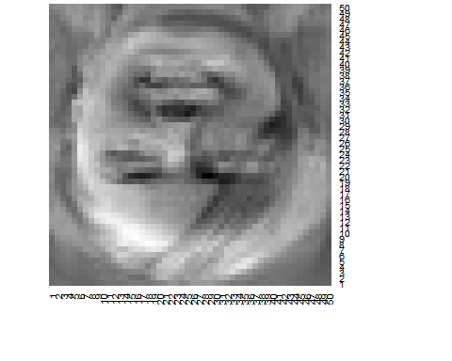

heatmap(newvec7,Rowv=NA,Colv=NA,col=grays, scale = "none")

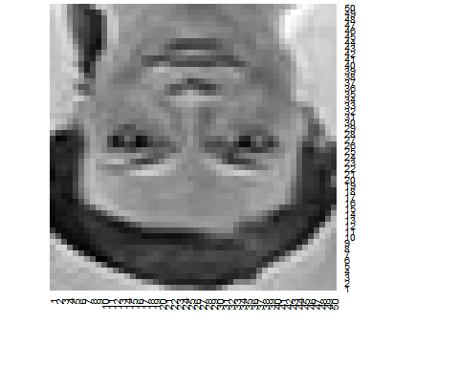

heatmap(newvec8,Rowv=NA,Colv=NA,col=grays, scale = "none")

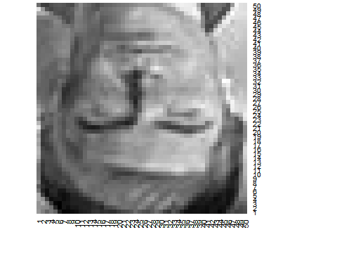

heatmap(newvec9,Rowv=NA,Colv=NA,col=grays, scale = "none")

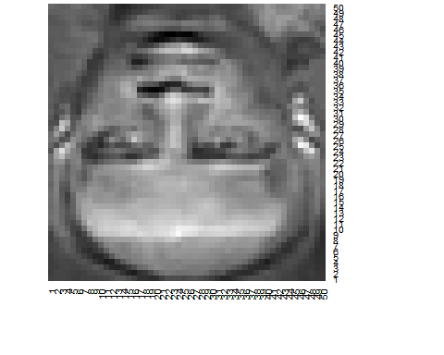

heatmap(newvec10,Rowv=NA,Colv=NA,col=grays, scale = "none")

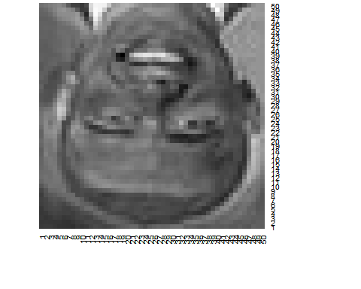

heatmap(mean,Rowv=NA,Colv=NA,col=grays, scale = "none")

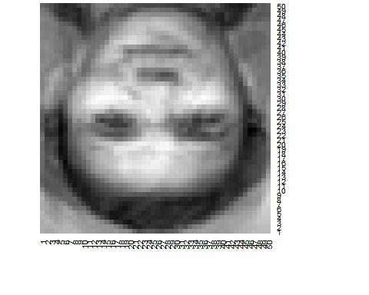

newmatrix <- cbind(as.vector(newvec1),as.vector(newvec2),as.vector(newvec3),  
 as.vector(newvec4),as.vector(newvec5),as.vector(newvec6),  
 as.vector(newvec7),as.vector(newvec8),as.vector(newvec9),as.vector(newvec10))

# Calculate covariance and eigen values.

covariance <- cov(newmatrix)  
eigenv <- eigen(covariance)  
eigenvalue <- eigenv $ values  
eigenvector <- eigenv $vectors  
plot(eigenvalue,type="l")

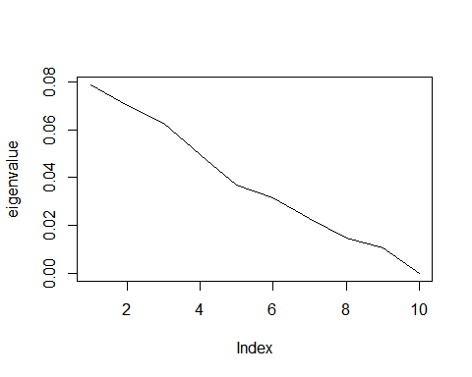

# Calculate the eigenvectors and display each face with respect to eigenvectors.

eigenvalue1 <- eigenvalue[1]  
eigenvalue2 <- eigenvalue[2]  
eigenvalue3 <- eigenvalue[3]  
eigenface1 <- eigenvalue1 * newmatrix  
eigenface2 <- eigenvalue2 * newmatrix  
eigenface3 <- eigenvalue3 * newmatrix  
eigenface <- eigenface1 + eigenface2 + eigenface3  
  
## eigenface 1  
eigenpic1 <- matrix(ncol=50, nrow=500)  
a <- matrix(ncol=1, nrow=2500)  
  
for (i in 1:10){  
 a<- eigenface1[,i]  
 dim(a)<-c(50,50)  
 eigenpic1[(50*(i-1)+1):(50*i),] <- a  
}  
  
for (i in 1:10){  
 heatmap(eigenpic1[(50*(i-1)+1):(50*i),],Rowv=NA,Colv=NA,col=grays, scale = "none")  
}



## eigenface 2  
eigenpic2 <- matrix(ncol=50, nrow=500)  
a <- matrix(ncol=1, nrow=2500)  
  
for (i in 1:10){  
 a<- eigenface2[,i]  
 dim(a)<-c(50,50)  
 eigenpic2[(50*(i-1)+1):(50*i),] <- a  
}  
  
for (i in 1:10){  
 heatmap(eigenpic2[(50*(i-1)+1):(50*i),],Rowv=NA,Colv=NA,col=grays, scale = "none")  
}



## eigenface 3  
eigenpic3 <- matrix(ncol=50, nrow=500)  
a <- matrix(ncol=1, nrow=2500)  
  
for (i in 1:10){  
 a<- eigenface3[,i]  
 dim(a)<-c(50,50)  
 eigenpic3[(50*(i-1)+1):(50*i),] <- a  
}  
  
for (i in 1:10){  
 heatmap(eigenpic3[(50*(i-1)+1):(50*i),],Rowv=NA,Colv=NA,col=grays, scale = "none")  
}



## eigenface  
eigenpic <- matrix(ncol=50, nrow=500)  
a <- matrix(ncol=1, nrow=2500)  
  
for (i in 1:10){  
 a<- eigenface[,i]  
 dim(a)<-c(50,50)  
 eigenpic[(50*(i-1)+1):(50*i),] <- a  
}  
  
  
for (i in 1:10){  
 heatmap(eigenpic[(50*(i-1)+1):(50*i),],Rowv=NA,Colv=NA,col=grays, scale = "none")  
}



Since there is no much difference in eigen values, there is no much difference in the eigen faces. Adding these values together does not improve the performance a lot.

# Test

## First test

First, test a picture that is exactly in the training.

test1 <- readJPEG("face2.jpg")  
featuretest1 <- as.vector(test1) - as.vector(mean)  
dis1 <- matrix(nrow=2500, ncol=10)  
distance1 <- c()  
for (i in 1:10) {  
 dis1[,i] <- eigenvalue1 * featuretest1 -eigenface1[,i]  
 distance1[i] <- sum(abs(dis1[,i]))/2500  
}  
  
distance1

## [1] 0.01712742 0.00000000 0.01871387 0.02240992 0.01657809 0.01354158  
## [7] 0.02367402 0.01612316 0.01622929 0.01073625

which.min(distance1)

## [1] 2

distance1[which.min(distance1)]

## [1] 0

This exactly meets the original picture. The distance is 0.

dis1 <- matrix(nrow=2500, ncol=10)  
distance1 <- c()  
for (i in 1:10) {  
 dis1[,i] <- eigenvalue2 * featuretest1 -eigenface2[,i]  
 distance1[i] <- sum(abs(dis1[,i]))/2500  
}  
  
distance1

## [1] 0.015254410 0.000000000 0.016667375 0.019959231 0.014765154  
## [6] 0.012060713 0.021085091 0.014359972 0.014454500 0.009562164

which.min(distance1)

## [1] 2

distance1[which.min(distance1)]

## [1] 0

When we use the second best engin value, the result is still the same, and the distance is still 0.

## Second test

test2 <- readJPEG("face12.jpg")  
test2 <- test2[,,1]  
heatmap(test2,Rowv=NA,Colv=NA,col=grays, scale = "none")

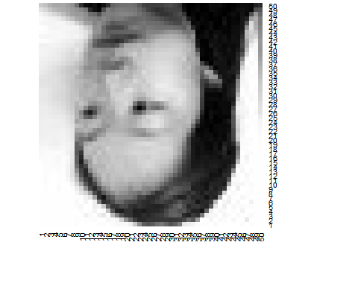

featuretest2 <- as.vector(test2) - as.vector(mean)  
dis2 <- matrix(nrow=2500, ncol=10)  
distance2 <- c()  
for (i in 1:10) {  
 dis2[,i] <- eigenvalue1 * featuretest2 -eigenface1[,i]  
 distance2[i] <- sum(abs(dis2[,i]))/2500  
}  
  
distance2

## [1] 0.02513939 0.02563349 0.02722946 0.02136007 0.02878651 0.02768686  
## [7] 0.02484743 0.03201081 0.02948645 0.02497370

which.min(distance2)

## [1] 4

distance2[which.min(distance2)]

## [1] 0.02136007

dis2 <- matrix(nrow=2500, ncol=10)  
distance2 <- c()  
for (i in 1:10) {  
 dis2[,i] <- eigenvalue2 * featuretest2 -eigenface2[,i]  
 distance2[i] <- sum(abs(dis2[,i]))/2500  
}  
  
distance2

## [1] 0.02239021 0.02283028 0.02425172 0.01902419 0.02563849 0.02465910  
## [7] 0.02213018 0.02851020 0.02626189 0.02224264

which.min(distance2)

## [1] 4

distance2[which.min(distance2)]

## [1] 0.01902419

When I plug in another my picture from a direction, it is recognized as the forth person, but the differneve between each picture is really small, the distance difference between 2nd and 4th is 0.04.

## Third test

test3 <- readJPEG("face11.jpg")  
heatmap(test3,Rowv=NA,Colv=NA,col=grays, scale = "none")

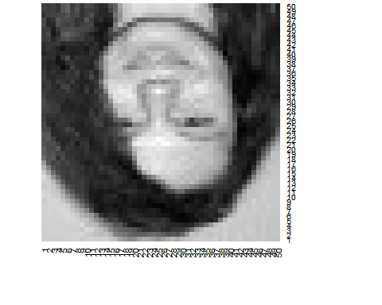

featuretest3 <- as.vector(test3) - as.vector(mean)  
dis3 <- matrix(nrow=2500, ncol=10)  
distance3 <- c()  
for (i in 1:10) {  
 dis3[,i] <- eigenvalue1 * featuretest3 -eigenface1[,i]  
 distance3[i] <- sum(abs(dis3[,i]))/2500  
}  
  
distance3

## [1] 0.01758717 0.01103266 0.01858352 0.02384156 0.01447134 0.01547313  
## [7] 0.02517880 0.01725752 0.01727371 0.01477763

which.min(distance3)

## [1] 2

distance3[which.min(distance3)]

## [1] 0.01103266